

04 - Iteration Control Structures

Department of Computer Science and Engineering

| Rajalakshmi Engineering College

PA. GE


Ex. No. : 4.1 Date: 10.04.2024

Register No.: 231401020 Name: BHUVANESWARI S

Factors of a number

Determine the factors of a number (i.e., all positive integer values that evenly divide into a number).
For example:

Inpu | Result
t | Result

- 124510
20

k=int(input())

l=[]

for i in range(1,k+1):

if(k%i==0):

l.append(i)

for j in l:

print(j,end=' ')

Department of Computer Science and Engineering | Rajalakshmi Engineering College

PA.

GE

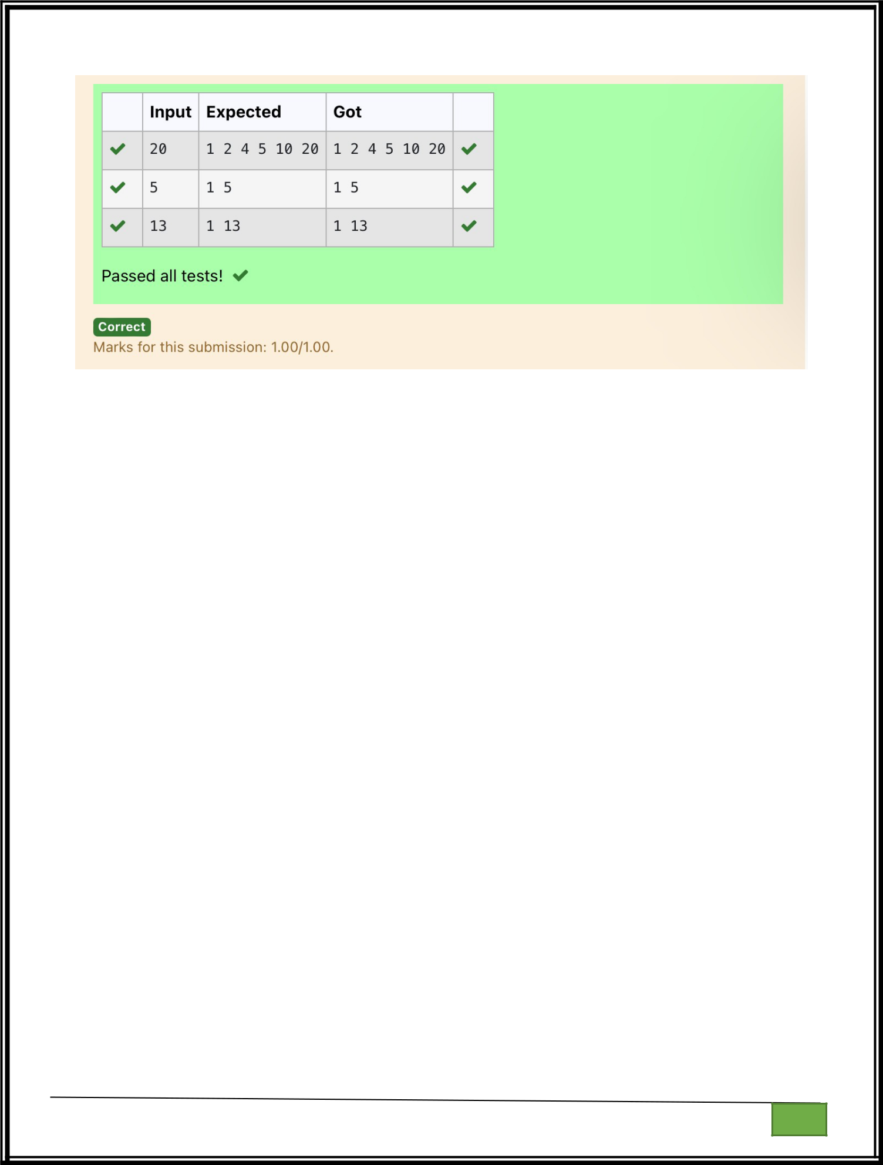

Department of Computer Science and Engineering

| Rajalakshmi Engineering College

PA. GE

Department of Computer Science and Engineering

| Rajalakshmi Engineering College

PA. GE
Ex. No. : 4.2 Date: 10.04.2024

Register No.: 231401020 Name: BHUVANESWARI S

Non Repeated Digit Count

Write a program to find the count of non- repeated digits in a given number N. The number will be passed to the program as an input of type int.

Assumption: The input number will be a positive integer number >= 1 and <= 25000.

Some examples are as below.
If the given number is 292, the program should return 1 because there is only 1 non-repeated digit '9' in this number

If the given number is 1015, the program should return 2 because there are 2 non-repeated digits in this number, '0', and '5'.

If the given number is 108, the program should return 3 because there are 3 non-repeated digits in this number, '1', '0', and '8'.

If the given number is 22, the function should return 0 because there are NO non-repeated digits in this number.

For example:

Input | Resul
Input | t
292 | 1
1015 | 2
108 | 3
22 | 0

n=int(input())
l=[]

k=[]
while n>0:

a=n%10
n=n//10

l.append(a)
for i in range(len(l)):

Department of Computer Science and Engineering | Rajalakshmi Engineering College

PA.

GE

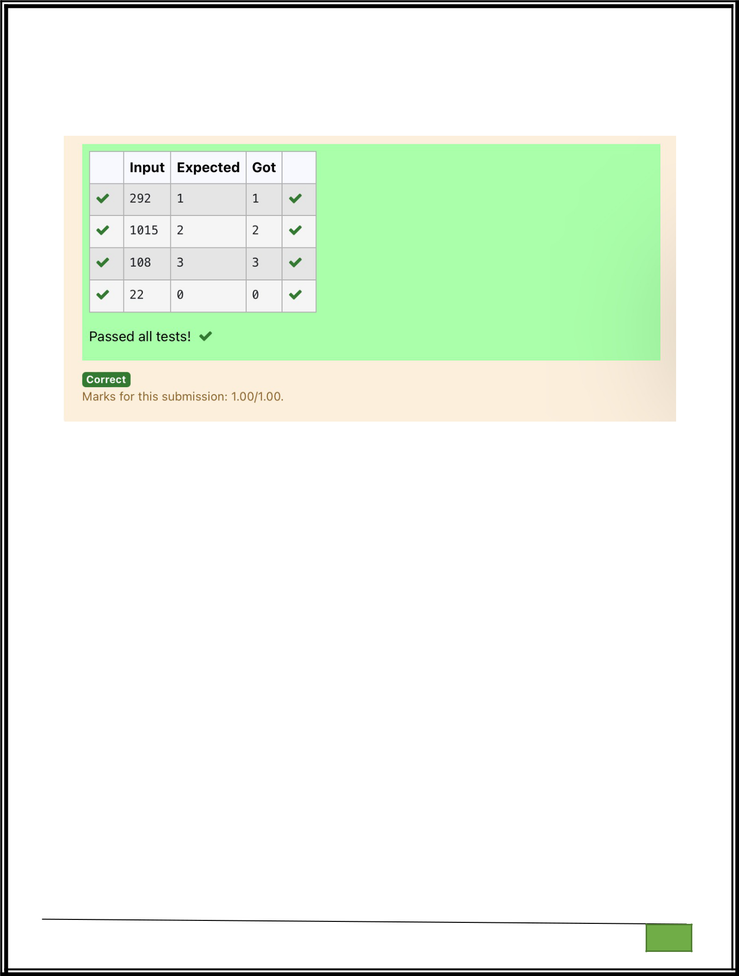
if l.count(l[i])==1:
k.append(l[i])

print(len(k))

Department of Computer Science and Engineering

| Rajalakshmi Engineering College

PA. GE

Department of Computer Science and Engineering

| Rajalakshmi Engineering College

PA. GE

Ex. No. : 4.3 Date: 10.04.2024

Register No.: 231401020 Name: BHUVANESWARI S

Prime Checking

Write a program that finds whether the given number N is Prime or not. If the number is prime, the program should return 2 else it must return 1.

Assumption: 2 <= N <=5000, where N is the given number.

Example1: if the given number N is 7, the method must return 2

Example2: if the given number N is 10, the method must return 1

For example:

Inpu | Result
t | Result

- 2

101

a=int(input())

for i in range(2,a):

if(a%2==0):

flag=0

elif(a%i!=0):

flag=1

else:

flag=0

if(flag==1):

print("2")

elif(flag==0):

print("1")

Department of Computer Science and Engineering | Rajalakshmi Engineering College

PA.

GE

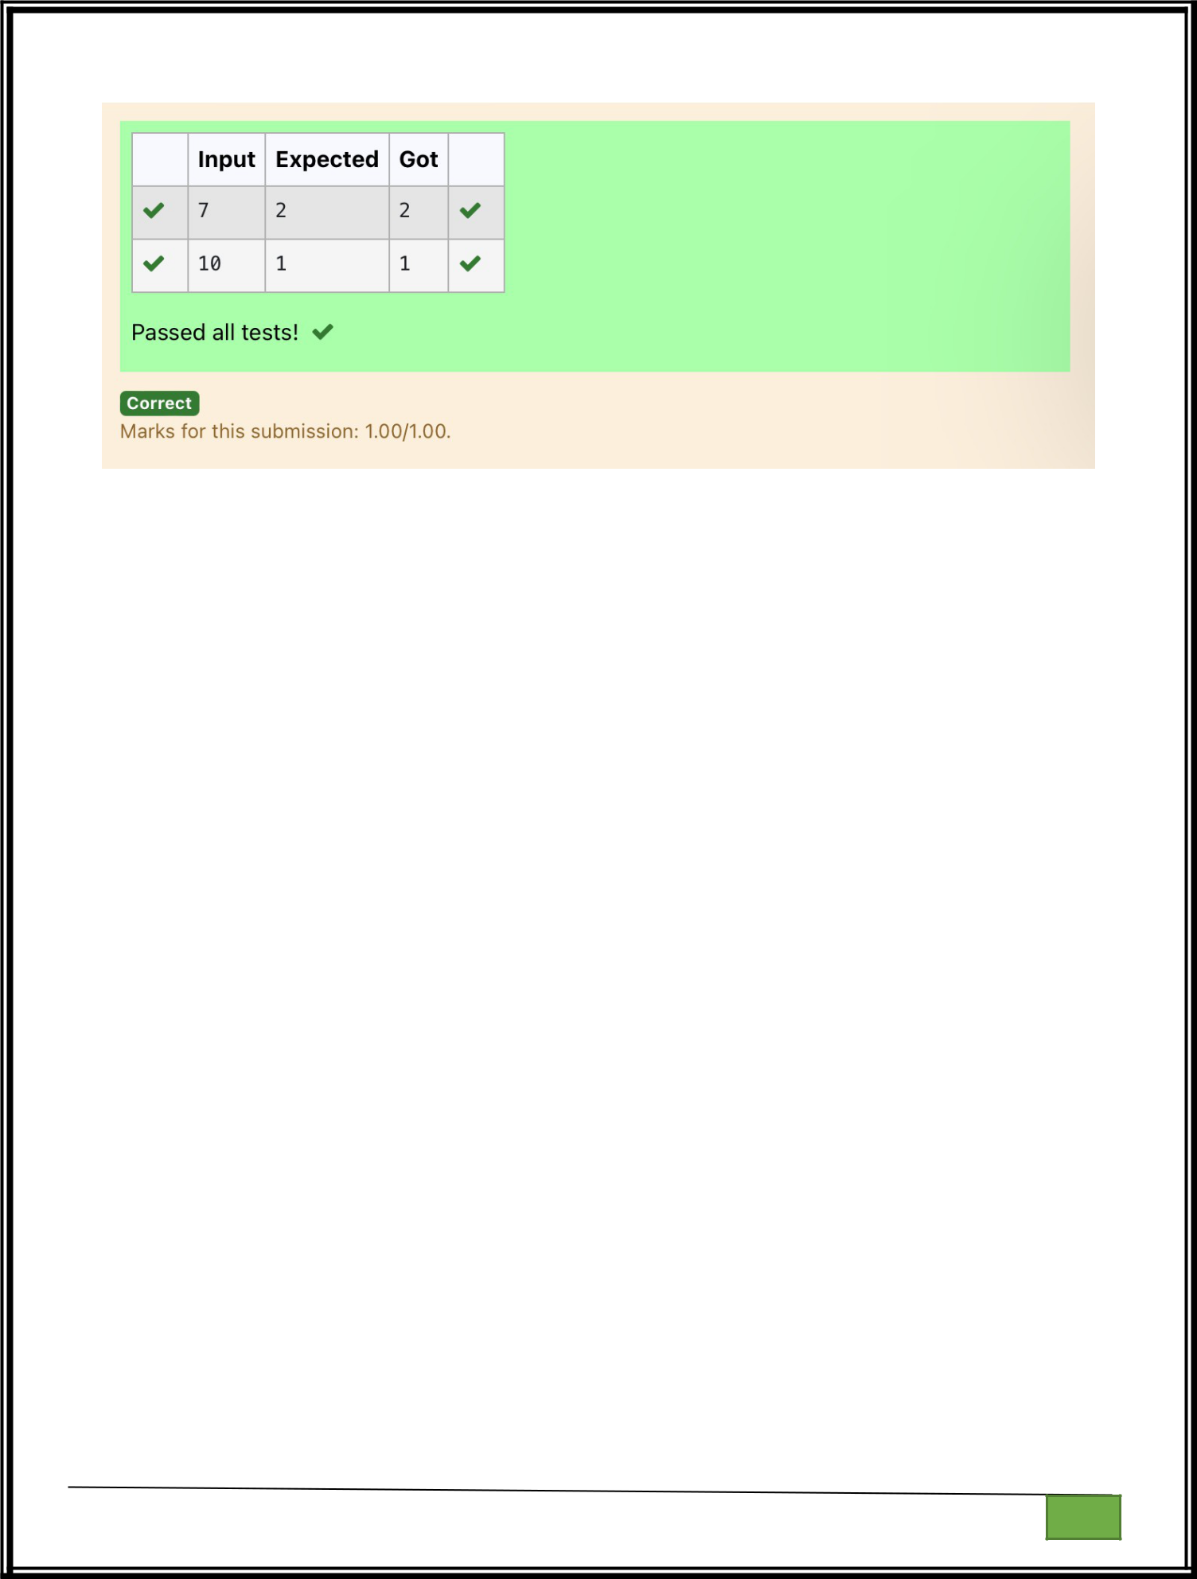

Department of Computer Science and Engineering

| Rajalakshmi Engineering College

PA. GE

Department of Computer Science and Engineering

| Rajalakshmi Engineering College

PA. GE
Ex. No. : 4.4 Date: 10.04.2024

Register No.: 231401020 Name: BHUVANESWARI S

Next Perfect Square

Given a number N, find the next perfect square greater than N.

Input Format:

Integer input from stdin.

Output Format:

Perfect square greater than N.

Example Input:

10

Output:

16

a=int(input())

c=[]

for i in range(0,a):

b=i**2

if(b>a):

c.append(b)

print(c[0])

Department of Computer Science and Engineering | Rajalakshmi Engineering College

PA.

GE

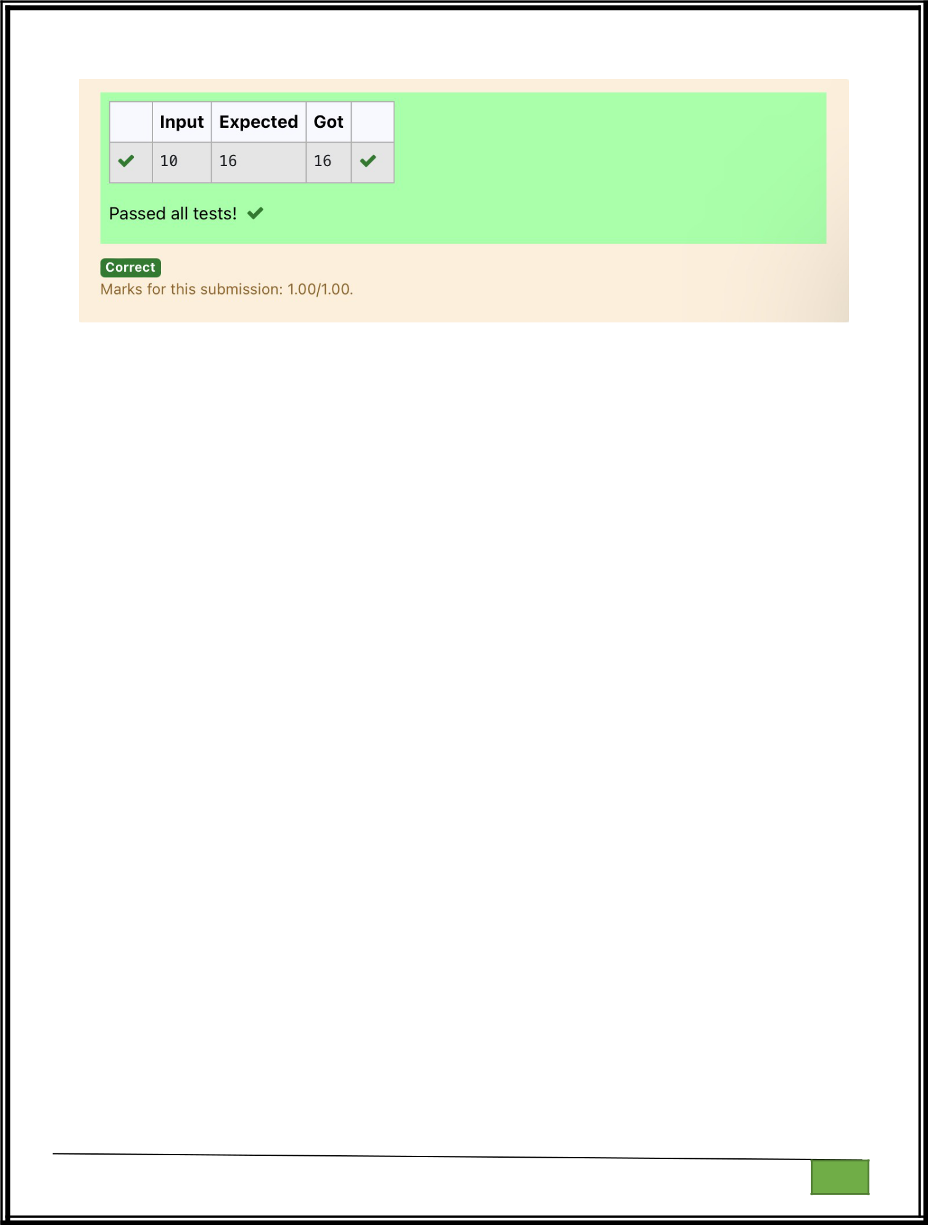

Department of Computer Science and Engineering

| Rajalakshmi Engineering College

PA. GE

Department of Computer Science and Engineering

| Rajalakshmi Engineering College

PA. GE
Ex. No. : 4.5 Date: 10.04.2024

Register No.: 231401020 Name: BHUVANESWARI S

Nth Fibonacci

Write a program to return the nth number in the fibonacci series. The value of N will be passed to the program as input.

NOTE: Fibonacci series looks like –

0, 1, 1, 2, 3, 5, 8, 13, 21, 34, 55, . . . and so on.

i.e. Fibonacci series starts with 0 and 1, and continues generating the next number as the sum of the previous two numbers.

- first Fibonacci number is 0,

- second Fibonacci number is 1,

- third Fibonacci number is 1,

- fourth Fibonacci number is 2,

- fifth Fibonacci number is 3,

- sixth Fibonacci number is 5,

- seventh Fibonacci number is 8, and so on.

For example:

Input:

7

Output

8

a=[0,1]

for i in range(0,100):

a.append(a[-1]+a[-2])

Department of Computer Science and Engineering | Rajalakshmi Engineering College

PA.

GE

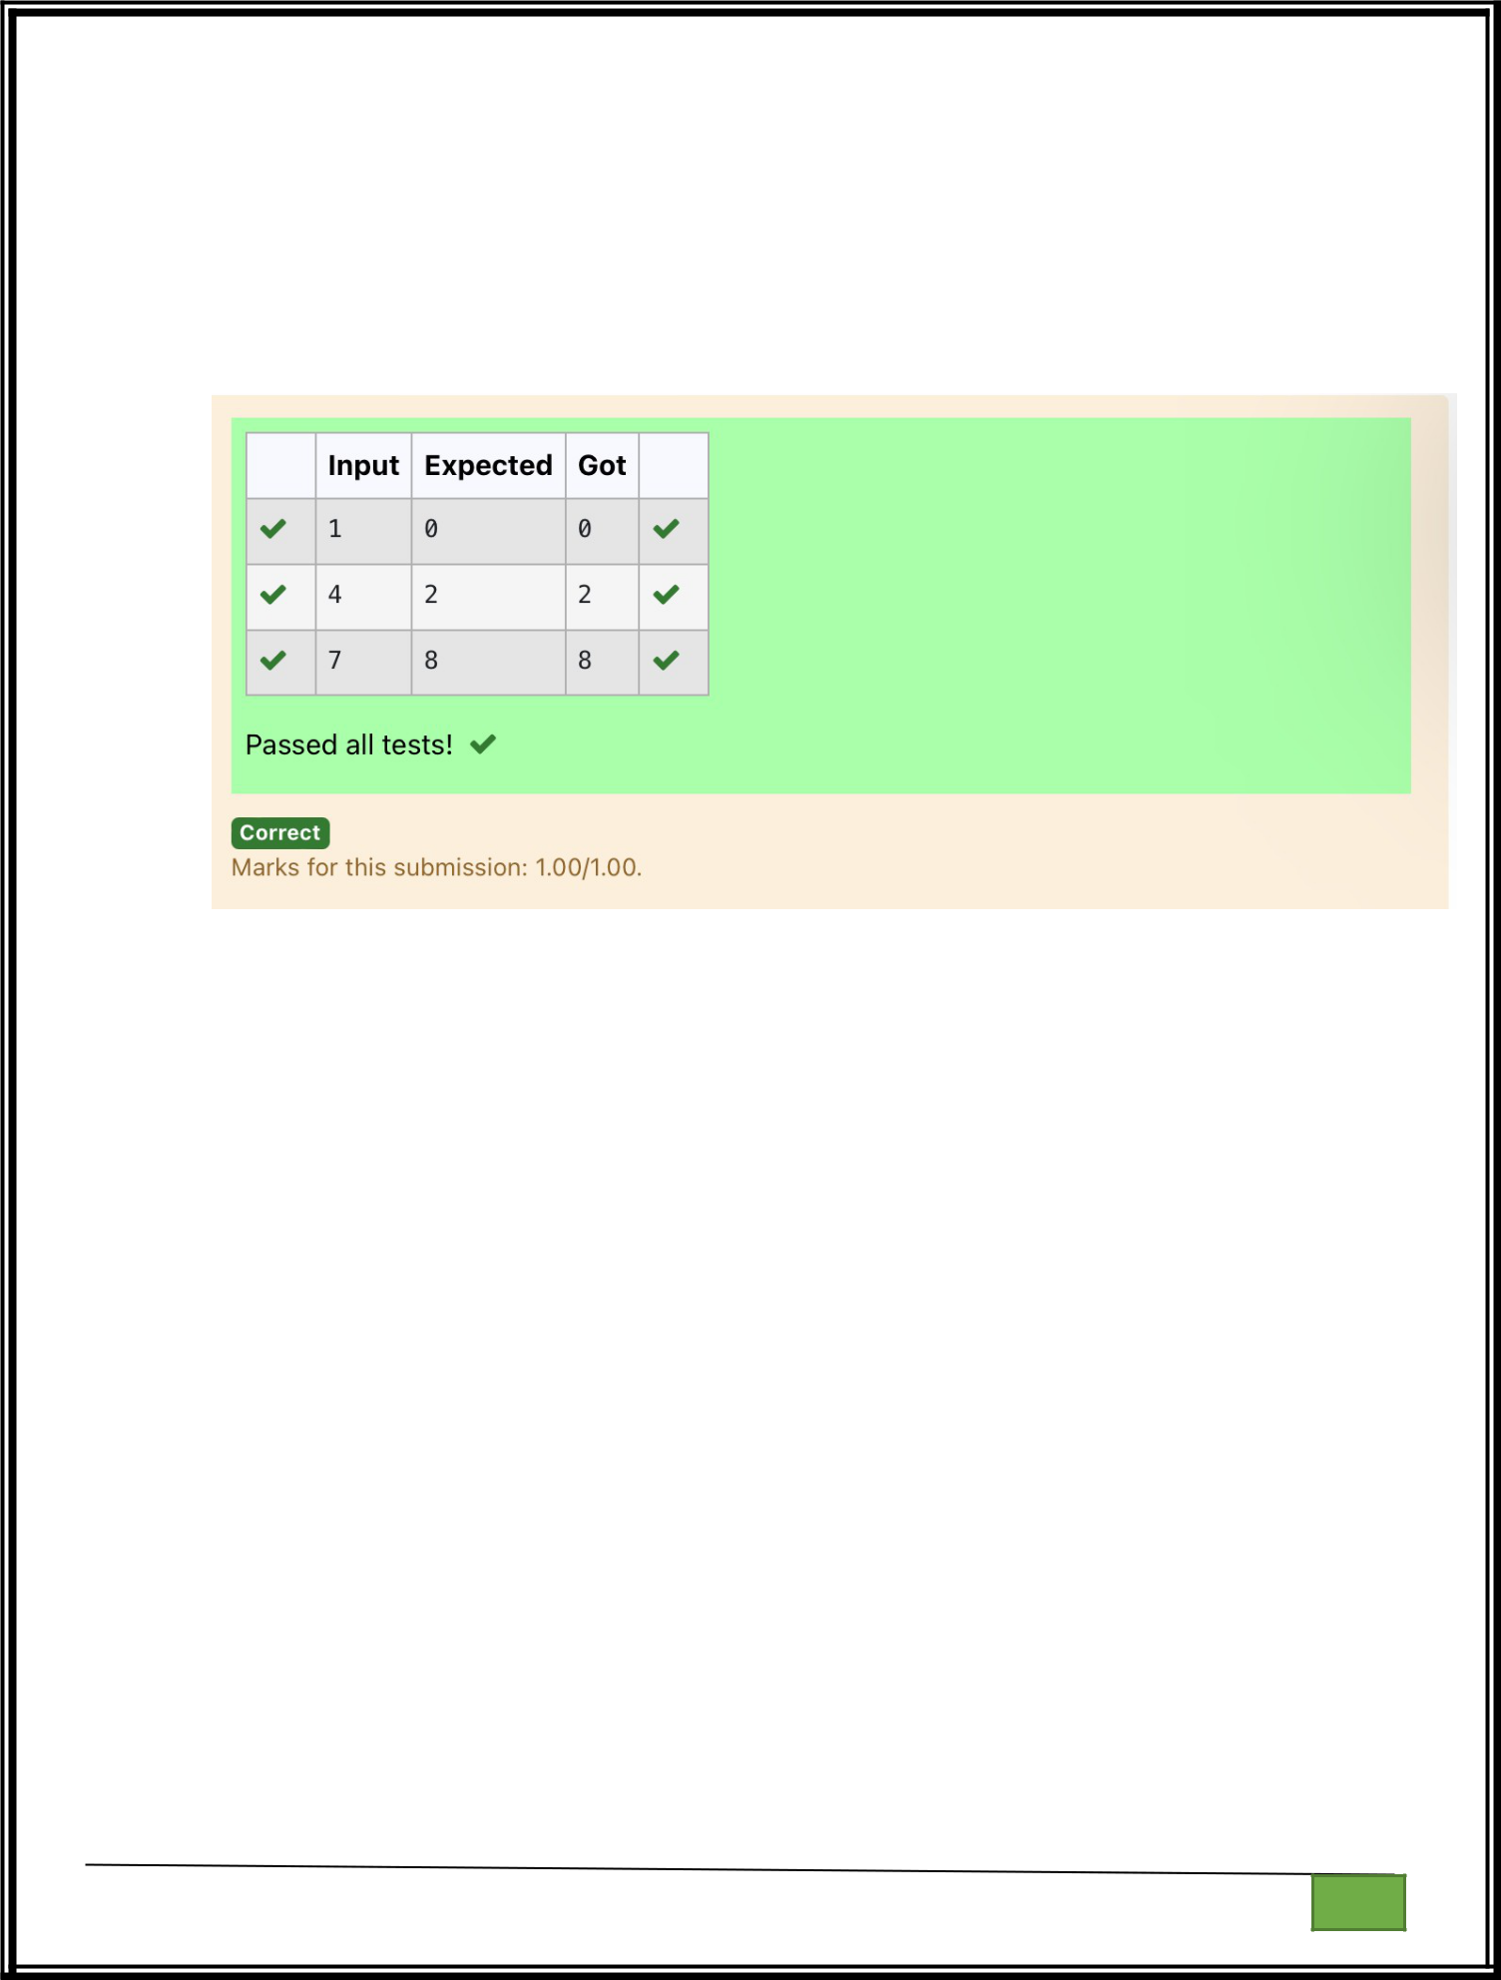
q=int(input())

print(a[q-1])

Department of Computer Science and Engineering

| Rajalakshmi Engineering College

PA. GE

Department of Computer Science and Engineering

| Rajalakshmi Engineering College

PA. GE
Ex. No. : 4.6 Date: 10.04.2024

Register No.: 231401020 Name :BHUVANESWARI S

Disarium Number

A Number is said to be Disarium number when the sum of its digit raised to the power of their respective positions becomes equal to the number itself. Write a program to print number is Disarium or not.

Input Format:

Single Integer Input from stdin.

Output Format:

Yes or No.

Example Input:

175

Output:

Yes

Explanation

1^1 + 7^2 +5^3 = 175

Example Input:

123

Output:

No

For example:

Inp Res
ut ult

- Yes

- No

Department of Computer Science and Engineering | Rajalakshmi Engineering College

PA.

GE

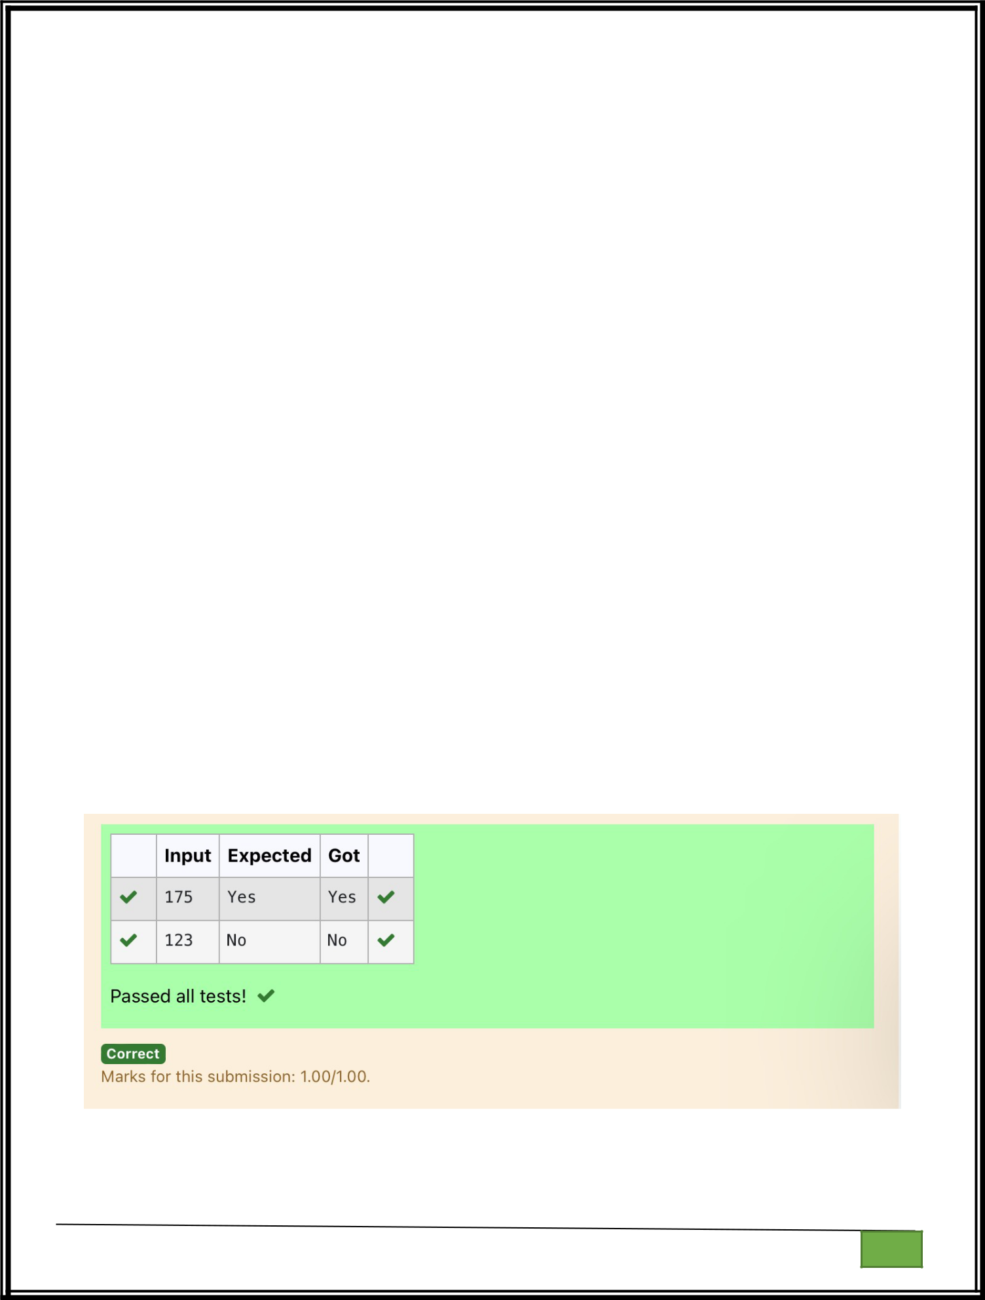
import math

n=int(input())

a=len(str(n))

sum=0

x=n

while(x!=0):

r=x%10

sum=int(sum+math.pow(r,a))

a-=1

x=x//10

if(sum==n):

print("Yes")

else:

print("No")

Department of Computer Science and Engineering

| Rajalakshmi Engineering College

PA. GE

Department of Computer Science and Engineering

| Rajalakshmi Engineering College

PA. GE

Ex. No. : 4.7 Date: 10.04.2024

Register No.: 231401020 Name: BHUVANESWARI S

Sum of Series

Write a program to find the sum of the series 1 +11 + 111 + 1111 + . . . + n terms (n will be given as input from the user and sum will be the output)

Sample Test Cases

Test Case 1

Input

4

Output

1234

Explanation:

as input is 4, have to take 4 terms.

1+11+111+1111

Test Case 2

Input

6

Output

123456

For example:

Inpu | Result
t | Result

- 123

n=int(input())

b=1

Department of Computer Science and Engineering | Rajalakshmi Engineering College

PA.

GE

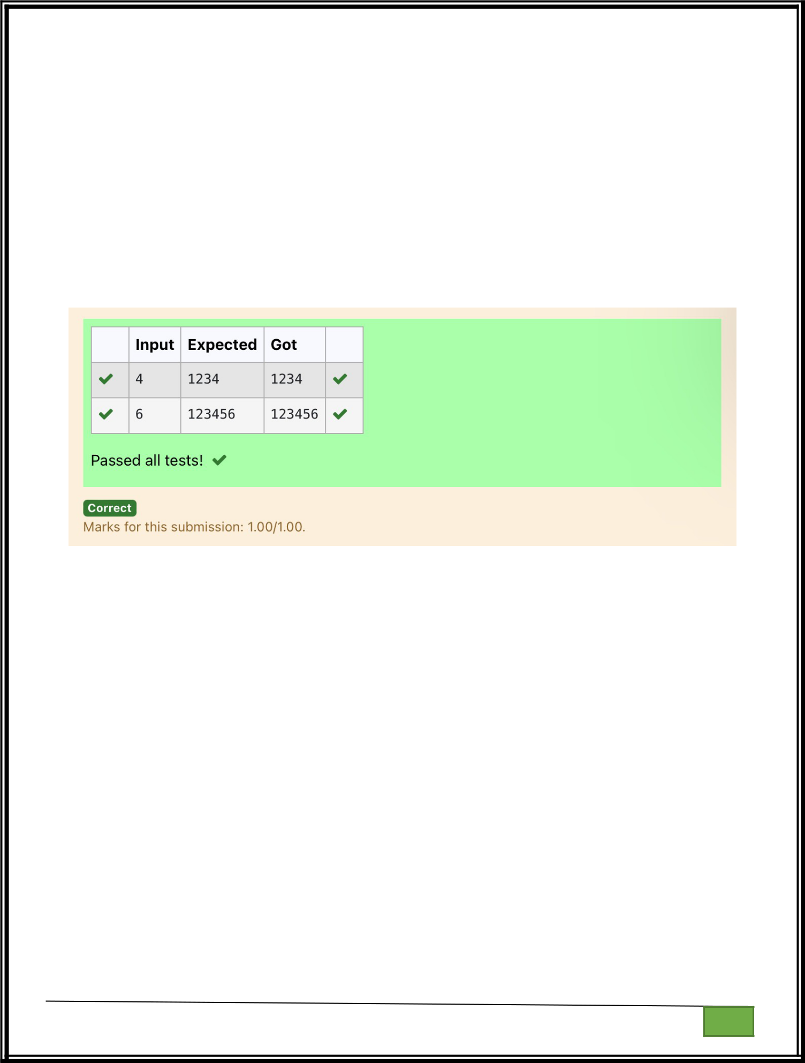
sum=0

for i in range(1,n+1):

sum+=b

b=(b*10)+1

print(sum)

Department of Computer Science and Engineering

| Rajalakshmi Engineering College

PA. GE

Department of Computer Science and Engineering

| Rajalakshmi Engineering College

PA. GE

Ex. No. | : | 4.8 | Date: 10.04.2024
Register No.: 231401020 |  |  | Name: BHUVANESWARI S
 |  |  | Unique Digit Count

Write a program to find the count of unique digits in a given number N. The number will be passed to the program as an input of type int.

Assumption: The input number will be a positive integer number >= 1 and <= 25000.
For e.g.

If the given number is 292, the program should return 2 because there are only 2 unique digits '2' and '9' in this number

If the given number is 1015, the program should return 3 because there are 3 unique digits in this number, '1', '0', and '5'.

For example:

Inpu | Result
t | Result

- 2

10153

a=int(input())

b=[]

while a>0:

c=a%10

a=a//10

b.append(c)

b=list(set(b))

print(len(b))

Department of Computer Science and Engineering | Rajalakshmi Engineering College

PA.

GE

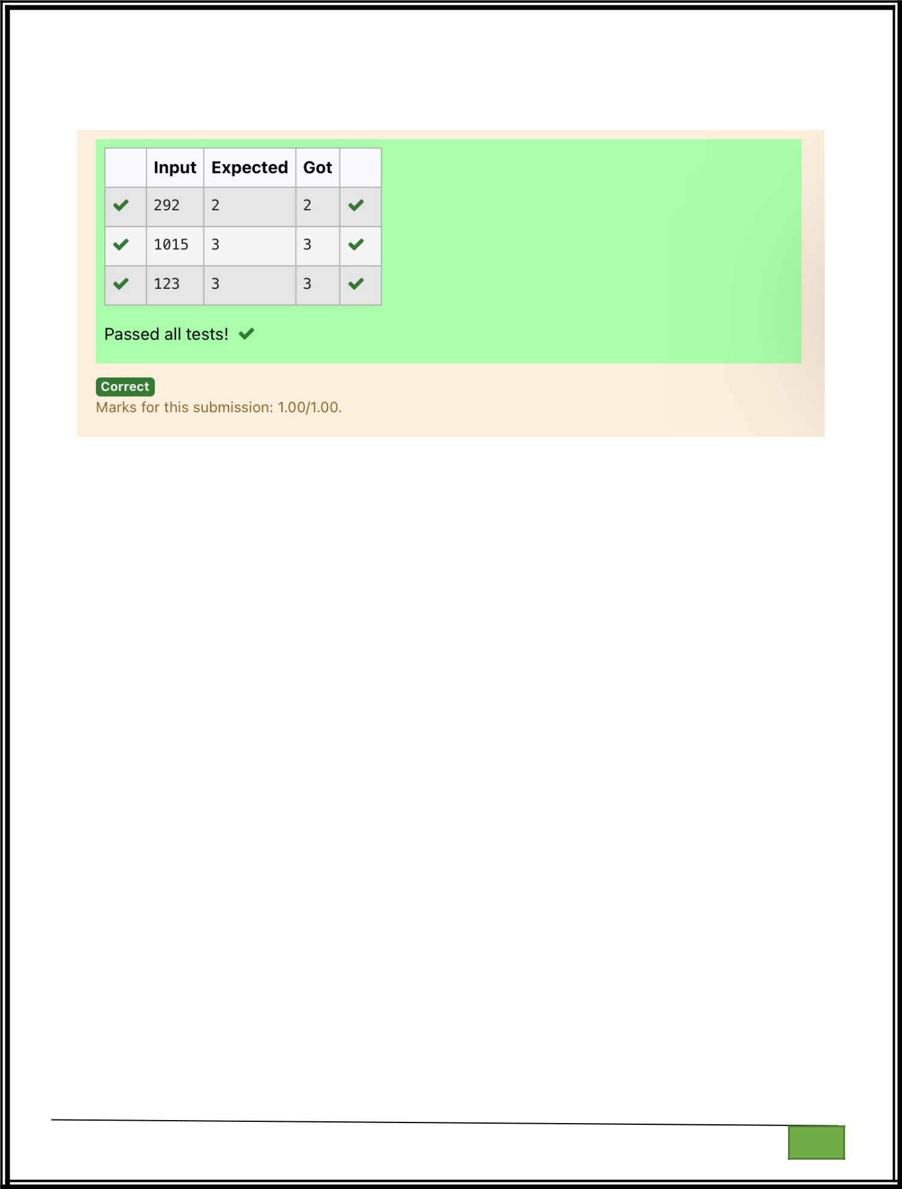

Department of Computer Science and Engineering

| Rajalakshmi Engineering College

PA. GE

Department of Computer Science and Engineering

| Rajalakshmi Engineering College

PA. GE
Ex. No. : 4.9 Date: 10.04.2024

Register No.: 231401020 Name: BHUVANESWARI S

Product of single digit

Given a positive integer N, check whether it can be represented as a product of single digit numbers.

Input Format:

Single Integer input.

Output Format:

Output displays Yes if condition satisfies else prints No.

Example Input:

14

Output:

Yes

Example Input:

13

Output:

No

a=int(input())

flag=0

for i in range(10):

for j in range(10):

if(i*j==a):

flag=1

break

if(flag==1):

print("Yes")

else:

Department of Computer Science and Engineering | Rajalakshmi Engineering College

PA.

GE

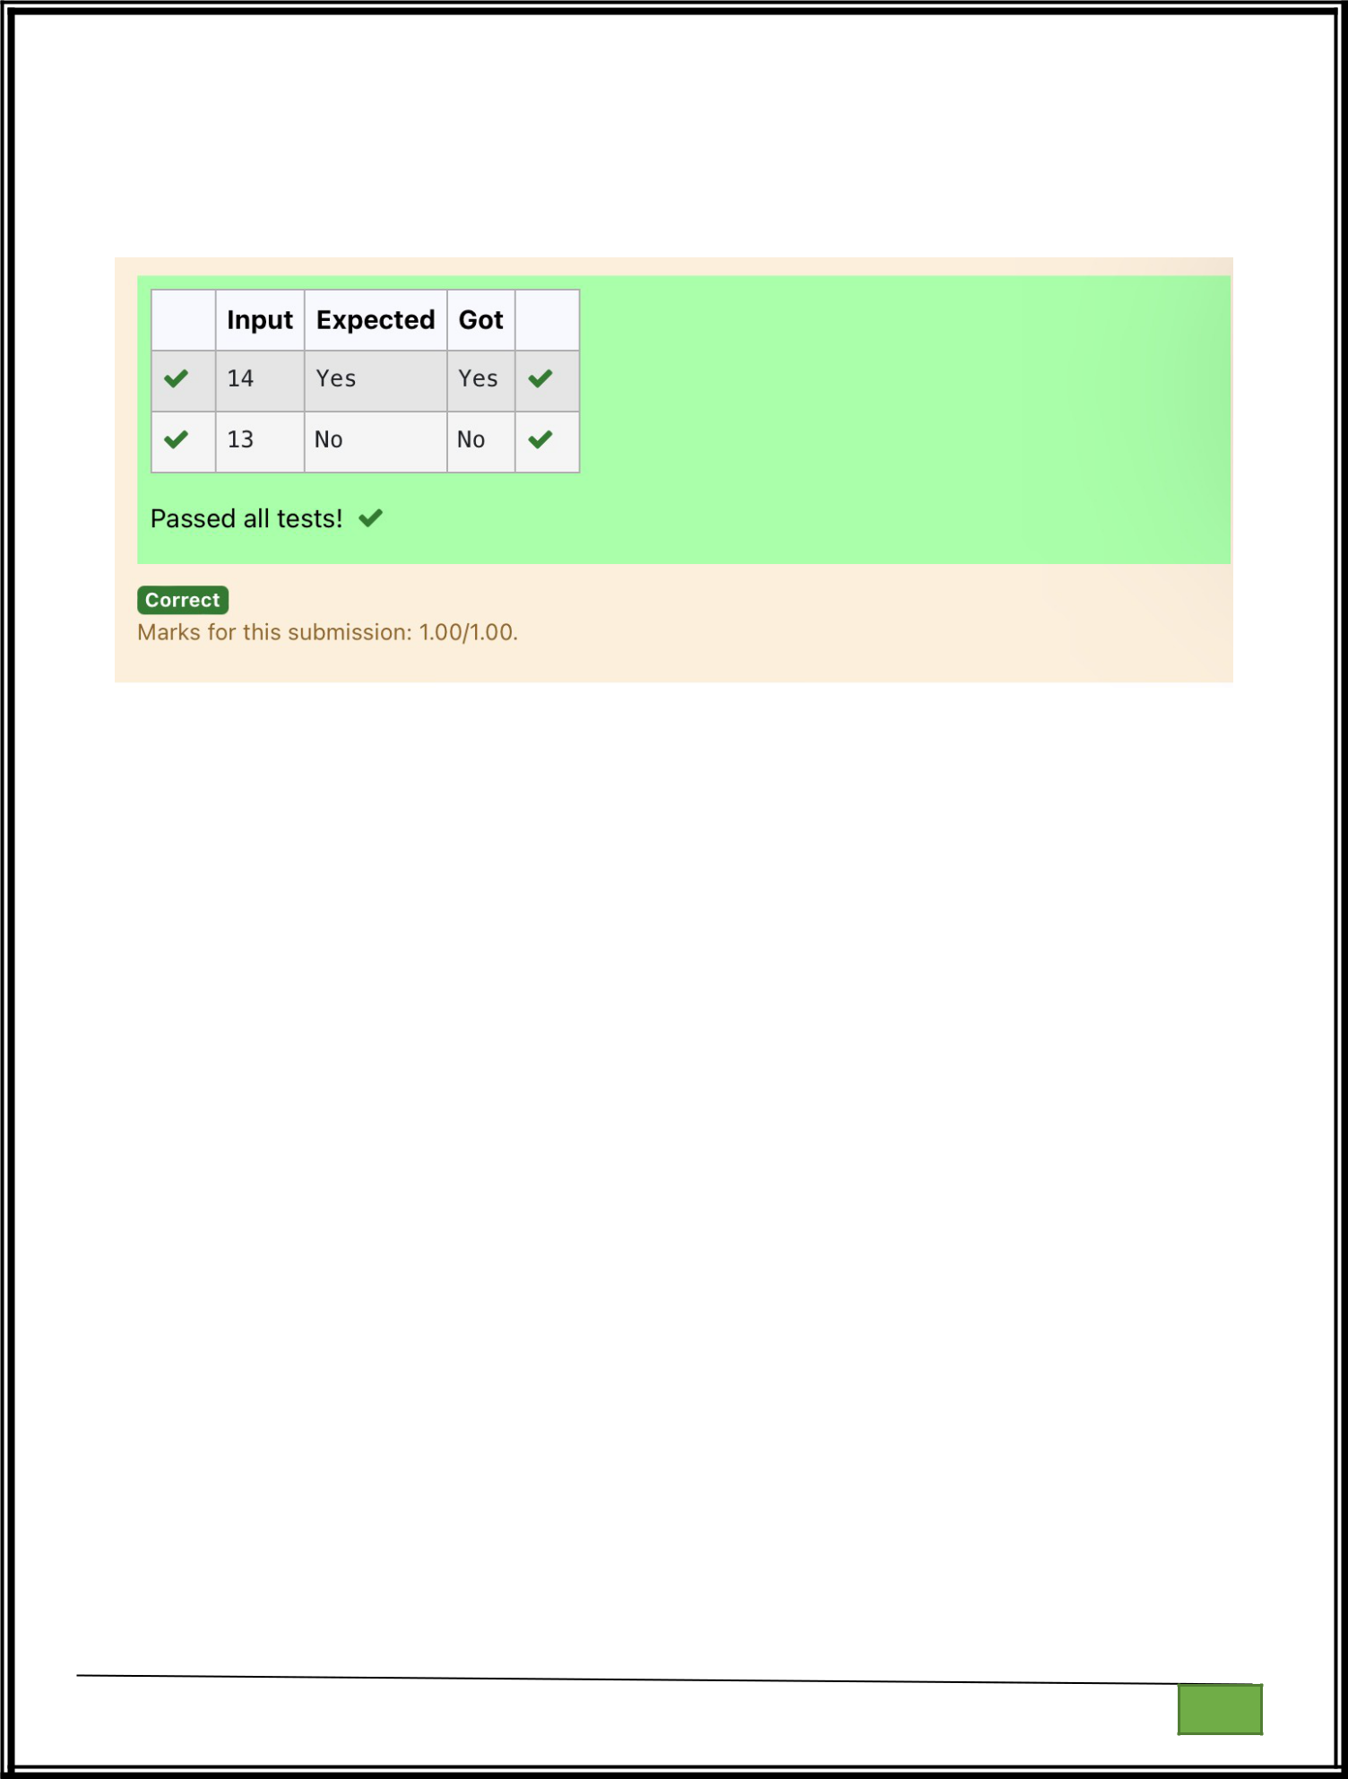
print("No")

Department of Computer Science and Engineering

| Rajalakshmi Engineering College

PA. GE

Department of Computer Science and Engineering

| Rajalakshmi Engineering College

PA. GE
Ex. No. : 4.10 Date: 10.04.2024

Register No.: 231401020 Name: BHUVANESWARI S

Perfect Square After adding One

Given an integer N, check whether N the given number can be made a perfect square after adding 1 to it.

Input Format:

Single integer input.

Output Format:

Yes or No.

Example Input:

24

Output:

Yes

Example Input:

26

Output:

No

For example:

Input | Resul
 | t
24 | Yes

import math

n=int(input())

a=n+1

Department of Computer Science and Engineering | Rajalakshmi Engineering College

PA.

GE

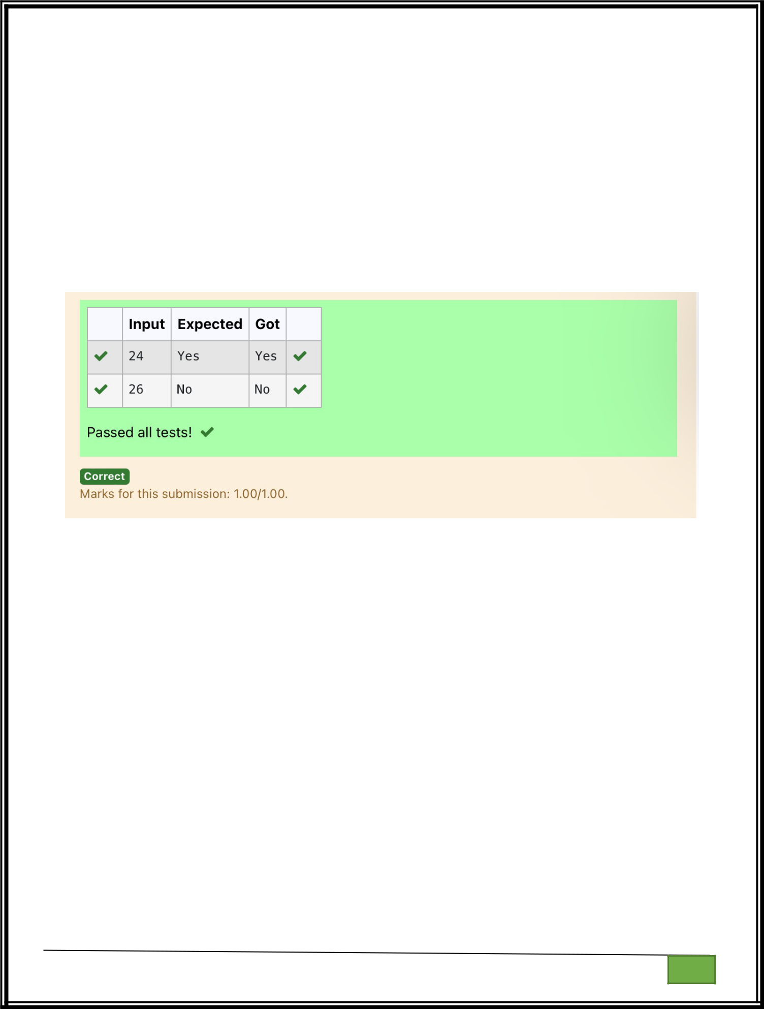
sr=int(math.sqrt(a))

if(sr*sr==a):

print("Yes")

else:

print("No")

Department of Computer Science and Engineering

| Rajalakshmi Engineering College

PA. GE

Department of Computer Science and Engineering

| Rajalakshmi Engineering College

PA. GE

